Routing 

| TERM | NAME – Student ID | COURSE CODE | WEIGHT |
| --- | --- | --- | --- |
|  | Click or tap here to enter text. | CSN105 | 8% |

Lab Objectives

Upon completion of this lab, you will be able to perform the following:

* Subnet a network based on network requirements
* Configure IP addressing on network devices
* Configure static routes on a router to route traffic from different networks
* Troubleshoot and resolve network connectivity issues

Lab Materials

* Pre-Lab Video: [Explanation](https://web.microsoftstream.com/video/8cefa3a7-724d-44bb-9ef8-c35678c7db36)
* Cisco Packet Tracer
* Network assigned to you in Blackboard under “My Grades”

Lab Instructions

* Install Cisco Packet Tracer or run application from MyApps
* Launch software and perform lab
* Enter your name and student ID above (Example: david – dtrinh)
* Answer questions and add screenshots into the corresponding textboxes
* Save the file on your computer for future reference
* Save the file again as a “.pdf” file
* Submit the PDF file for grading

Part 1: Network Scenario

In our previous network scenario, we experienced an issue with our router handling more than 2 networks. Our options were to replace the router or introduce another router. We chose to replace the router that allowed for 3 networks. In this lab, we will introduce another router to attach the new school to the network.

Our current network topology should look like the following:

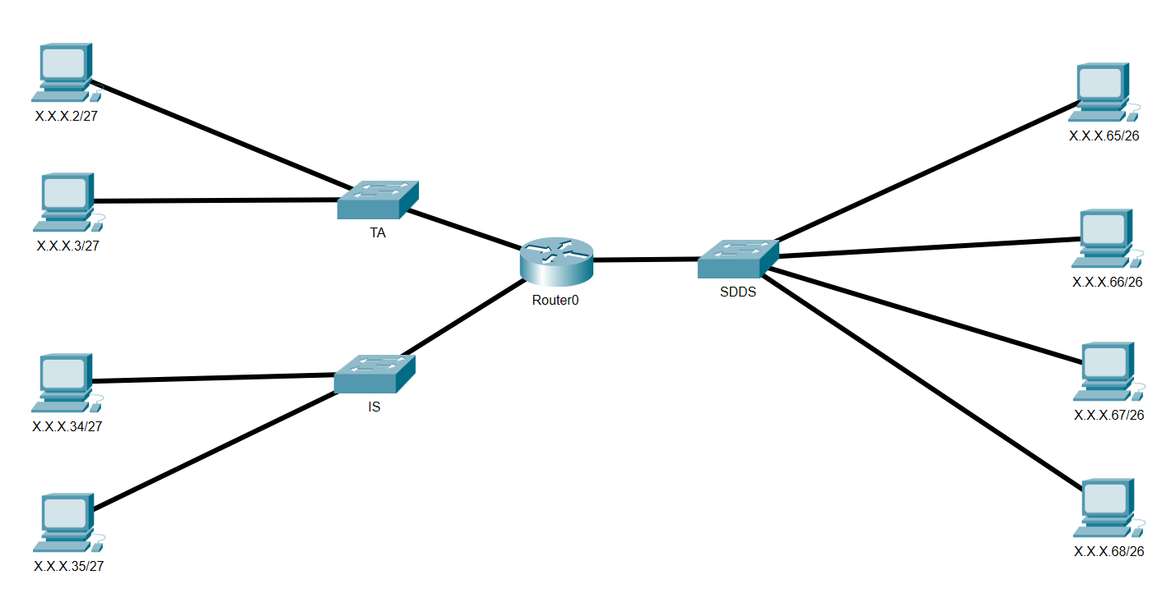

We will introduce another router and connect the “TA” network to the new router. The new router will then connect to the existing router. Using static routes, we will configure both routers to ensure network connectivity between the schools.

Part 2: New Router

1. Change the existing router’s display name to “R1”.
2. Add a 2911 router and change the display name to “R2”.

**Remember to power on all the ports on the router.**

1. Disconnect the TA network from R1 and connect it to R2.

**When removing the TA network connection from R1, we need to remember which port was used. That port will need to be reconfigured later.**

1. Configure R2 with the appropriate gateway IP address used in the TA network. You can check the gateway settings used in the PCs on the TA network to confirm the IP address and subnet mask used.
2. Confirm the PCs on the TA network can ping R2.

**Screenshot 2.0: New Topology [1 mark]**



Part 3: Configuring 2 Routers

1. Attach R1 and R2 using the appropriate network cable.

**Remember which port is used on each router so you select the correct port when configuring network settings.**

1. Confirm if a TA PC can “ping” a PC in another network.

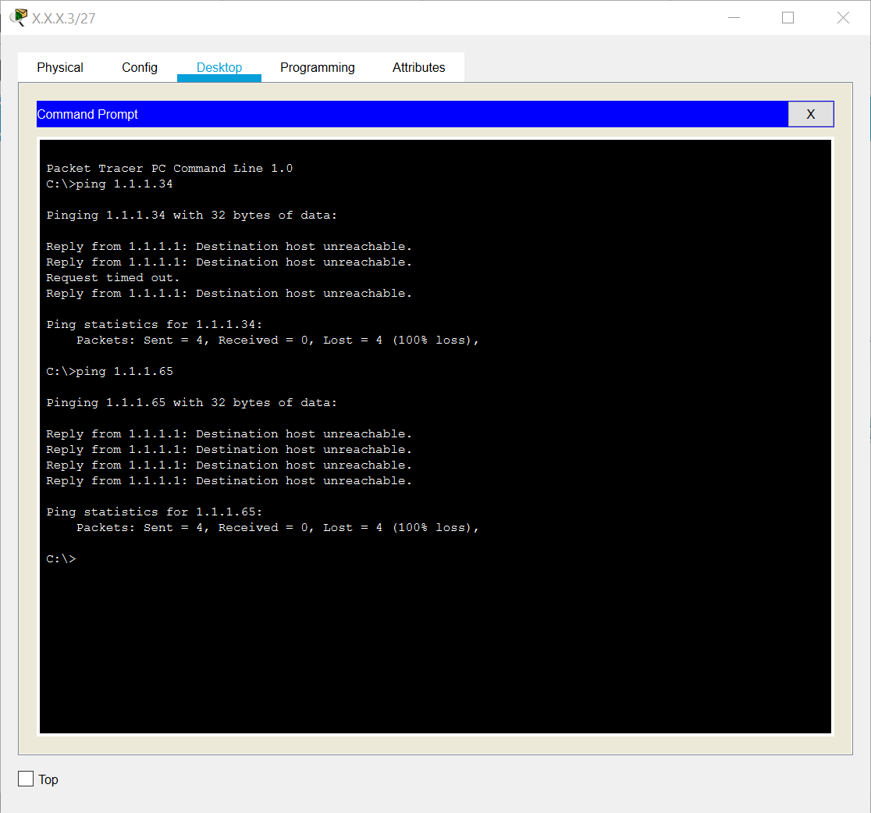

When connecting the R1 and R2 together, it created a new network segment between them. The data packets being sent from the TA network is not being routed properly to the other networks. This resulted in an error of “Destination host unreachable” when we attempted to “ping” other PCs. Since we introduced a new network segment, we will use a network of 192.168.1.0/29 to assign addresses to the routers.

|  |  |  |  |
| --- | --- | --- | --- |
| **What is the range for this network? [1 mark]** | | | |
| **Network** | **Subnet Mask** | **First available IP** | **Last available IP** |
| Click or tap here to enter text. | Click or tap here to enter text. | Click or tap here to enter text. | Click or tap here to enter text. |

**R1 and R2 Network Segment**

1. In the R1 properties, configure the port connected to R2 with the first available IP address.
2. In the R2 properties, configure the port connected to R1 with the last available IP address.

**Router R2**

**The R2 router is connected directly to the TA network and the R1-R2 network segment. It does not have information about the routes to the IS and SDDS networks. We will need to create 2 static route entries.**

1. In the R2 properties, navigate to “Config” and the “Static” submenu.
   1. Network: enter the Network ID of the IS network.
   2. Mask: enter the appropriate subnet mask.
   3. Next Hop: enter the IP address of the next router.
   4. Click “Add” to add the entry into the router’s routing table.
2. Using the same method, add another static route entry for the SDDS network.

|  |  |  |
| --- | --- | --- |
| **What are the entries for each static route? [1 mark]** | | |
| **Network** | **Mask** | **Next Hop** |
| Click or tap here to enter text. | Click or tap here to enter text. | Click or tap here to enter text. |
| Click or tap here to enter text. | Click or tap here to enter text. | Click or tap here to enter text. |

**Router R1**

**The R1 router is connected directly to both the IS and SDDS networks. It does not have information about the route to the TA network. We will only need 1 static route entry.**

1. In the R1 properties, navigate to “Config” and the “Static” submenu.
   1. Network: enter the Network ID of the TA network.
   2. Mask: enter the appropriate subnet mask.
   3. Next Hop: enter the IP address of the next router.
   4. Click “Add” to add the entry into the router’s routing table.

|  |  |  |
| --- | --- | --- |
| **What is the entry for the static route? [1 mark]** | | |
| **Network** | **Mask** | **Next Hop** |
| Click or tap here to enter text. | Click or tap here to enter text. | Click or tap here to enter text. |

To ensure proper network connectivity between the networks, confirm the PCs in each network can “ping” each other.

**Screenshot 3.1: PCs “ping” response from TA and IS networks [1 mark]**



**Screenshot 3.2: PCs “ping” response from TA and SDDS networks [1 mark]**



**Screenshot 3.3: PCs “ping” response from IS and SDDS networks [1 mark]**



Part 4: Configuring 3 Routers

Unfortunately, all computer hardware equipment will eventually fail. Although we cannot control when computer hardware will fail, we can minimize the impact it has on the network environment. In our network, the TA, IS, and SDDS departments are connected to each other. However, if router R1 were to fail, all the departments would no longer be connected to each other. We will introduce another router and interconnect all the routers to help minimize outages.

The TA network is currently connected directly to R2 whereas the IS and SDDS networks are connected directly to R1. We will remove a network from R1 and connect that network to a new router.

1. Add a 2911 router and change the display name to “R3”.

**Remember to power on all the ports on the router.**

1. Disconnect the SDDS network from R1 and connect it to R3.

**When removing the SDDS network connection from R1, we need to remember which port was used. That port will need to be reconfigured later.**

1. Configure R3 with the appropriate gateway IP address used in the SDDS network. You can check the gateway settings used in the PCs on the SDDS network to confirm the IP address and subnet mask used.
2. Confirm the PCs on the SDDS network can ping R3.
3. Using the appropriate network cables, connect R2 to R3 and R1 to R3.

We created 2 new network segments when connecting R2, R3 together and R1, R3 together. We will use 192.168.2.0/30 for R2, R3 segment and 192.168.3.0/30 for R1, R3 segment.

|  |  |  |  |
| --- | --- | --- | --- |
| **What is the range for each network? [1 mark]** | | | |
| **Network** | **Subnet Mask** | **1st available IP** | **Last available IP** |
| Click or tap here to enter text. | Click or tap here to enter text. | Click or tap here to enter text. | Click or tap here to enter text. |
| Click or tap here to enter text. | Click or tap here to enter text. | Click or tap here to enter text. | Click or tap here to enter text. |

**R2 and R3 Network Segment**

1. In the R2 properties, configure the port connected to R3 with the first available IP address.
2. In the R3 properties, configure the port connected to R2 with the last available IP address.

**R1 and R3 Network Segment**

1. In the R1 properties, configure the port connected to R3 with the first available IP address.
2. In the R3 properties, configure the port connected to R1 with the last available IP address.

After introducing another router, it has created 2 possible routes between each network. Example:

1. IS to TA can route packets R1-R2 or R1-R3-R2.
2. IS to SDDS can route packets R1-R3 or R1-R2-R3.

We will need to configure 4 static routes for each router.

**Router 1**

|  |  |  |
| --- | --- | --- |
| **What are the routing entries for Router 1? [1 mark]** | | |
| **Network** | **Mask** | **Next Hop** |
| Click or tap here to enter text. | Click or tap here to enter text. | Click or tap here to enter text. |
| Click or tap here to enter text. | Click or tap here to enter text. | Click or tap here to enter text. |
| Click or tap here to enter text. | Click or tap here to enter text. | Click or tap here to enter text. |
| Click or tap here to enter text. | Click or tap here to enter text. | Click or tap here to enter text. |

**Router 2**

|  |  |  |
| --- | --- | --- |
| **What are the routing entries for Router 2? [1 mark]** | | |
| **Network** | **Mask** | **Next Hop** |
| Click or tap here to enter text. | Click or tap here to enter text. | Click or tap here to enter text. |
| Click or tap here to enter text. | Click or tap here to enter text. | Click or tap here to enter text. |
| Click or tap here to enter text. | Click or tap here to enter text. | Click or tap here to enter text. |
| Click or tap here to enter text. | Click or tap here to enter text. | Click or tap here to enter text. |

**Router 3**

|  |  |  |
| --- | --- | --- |
| **What are the routing entries for Router 3? [1 mark]** | | |
| **Network** | **Mask** | **Next Hop** |
| Click or tap here to enter text. | Click or tap here to enter text. | Click or tap here to enter text. |
| Click or tap here to enter text. | Click or tap here to enter text. | Click or tap here to enter text. |
| Click or tap here to enter text. | Click or tap here to enter text. | Click or tap here to enter text. |
| Click or tap here to enter text. | Click or tap here to enter text. | Click or tap here to enter text. |

To ensure proper network connectivity between the networks, confirm the PCs in each network can “ping” each other.

**Explain one advantage and one disadvantage of your network configuration. [2 marks]**

Click or tap here to enter text.